**Style Guide - Papaya**

Overall look:

Spiritfarer/Minute of Islands style – clean/simple, kept simplistic but atmospheric

Lineart:

* Consistent linework for both face and body
* Use of small accent lines to give illusion of detail/noise
* Outer line width: 15px (on A4)
* Inner line width: 8px (on A4)

Shading:

* Simple and minimal cel-shading
* Most detail will be in lineart, shading should be simple – just enough to imply depth/shadows
* Soft use of gradients to imply direction of shadows

Lighting:

* Lighting should be kept simple like shading
* Overlay/colour layers should be used to match lighting to the scene (if it’s required)
* Soft use of gradients to imply direction of lighting
* No rim lighting

Background:

* Don’t make too overly complicated/busy: business/noise can be implied with use heavy use of accent lines
* Like characters backgrounds should be lineart-heavy
* Use gradients/colour layers for ambient lighting
* Backgrounds should be vibrant unless level specifies desaturation
* Darker hues, colder tones for nighttime - lighter hues, warmer tones for daytime
* Focus is on the character not on the background

Links:

<https://minute-of-islands.com>

https://store.steampowered.com/app/972660/Spiritfarer/

**RACES: STYLE & COLOUR PALETTES**

Humans:

* Rugged features
* Simple lines
* Neutral, generally warmer colours
* rich accents: **reds**/blues/purples
* Normal ears
* Avoid: very light/pastel, pink

Seraphs:

* Clean, softer features
* Clean, semi-natural lines
* Warm, pastel, white colours
* Normal ears
* Cool accents: **gold**, black (minimal)
* Avoid: dark/deep, green

Unburnt:

* Sharper features
* Angular/sharp lines
* Cool/cold, dark, black colours
* Normal ears
* Warm accents: **reds**, silver, blue
* Avoid: light/pastel, green, yellow

Elves:

* Semi-sharp features
* Smooth lines
* Neutral, light to dark, blue-ish colours
* Pointed ears
* Neutral accents: **silver**, gold, red
* Avoid: green, yellow, pink

Dryads:

* Soft features
* Natural lines
* Warm/cool, earthy, nature, green colours
* Pointed ears
* Neutral accents: **brown**
* Avoid: metallic, bright white, black, pink, brighter red, purple, orange

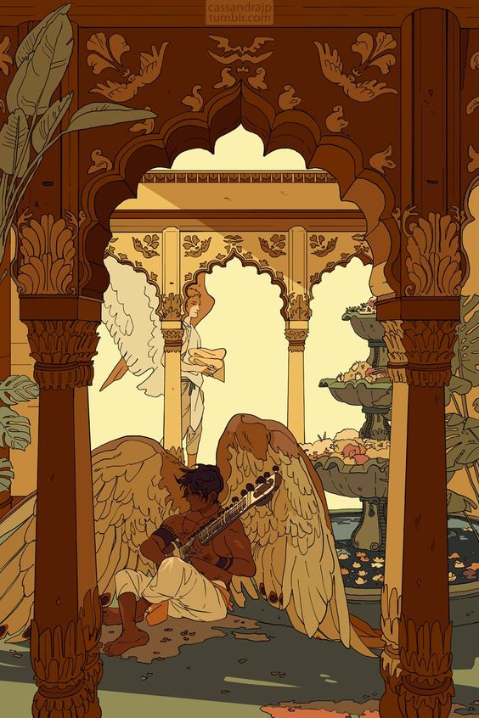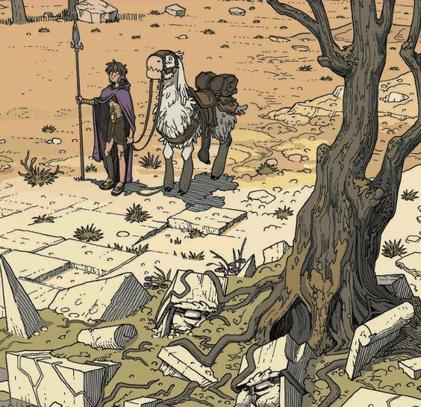**EXAMPLES**

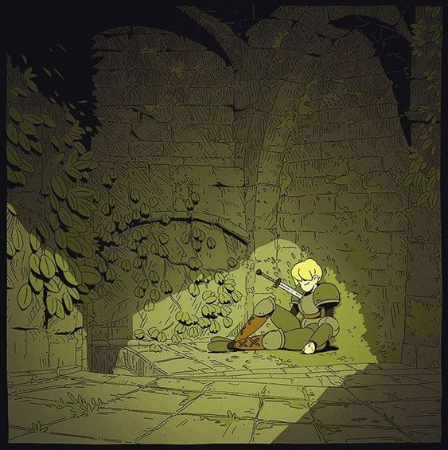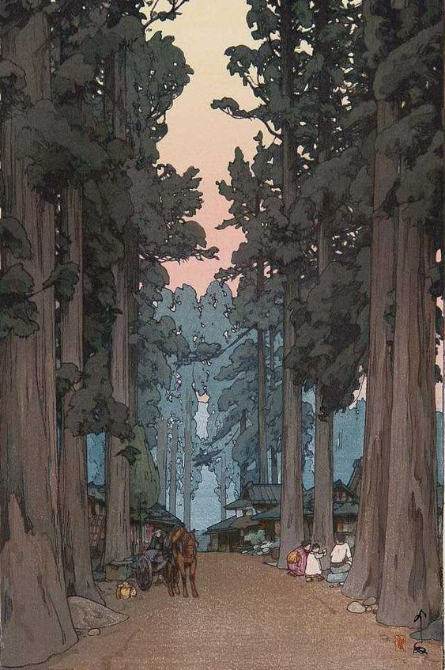

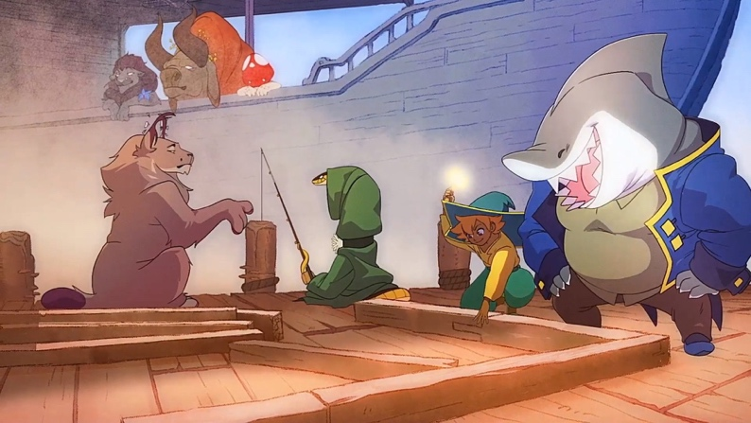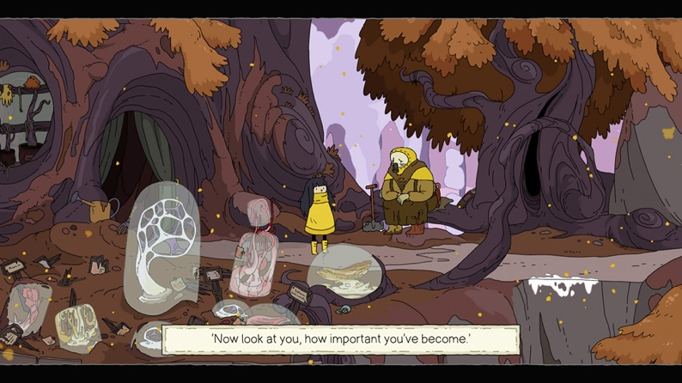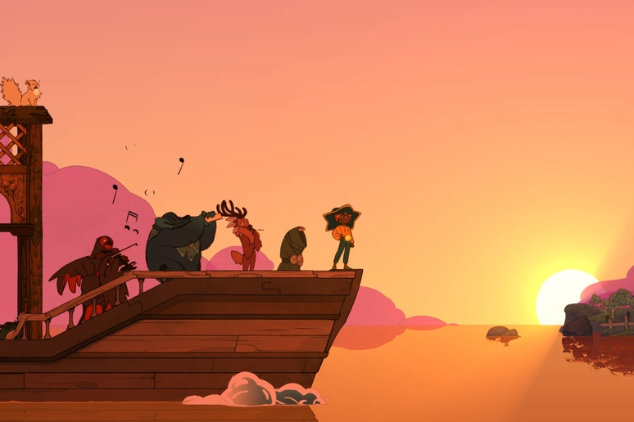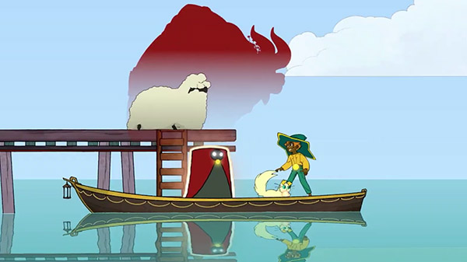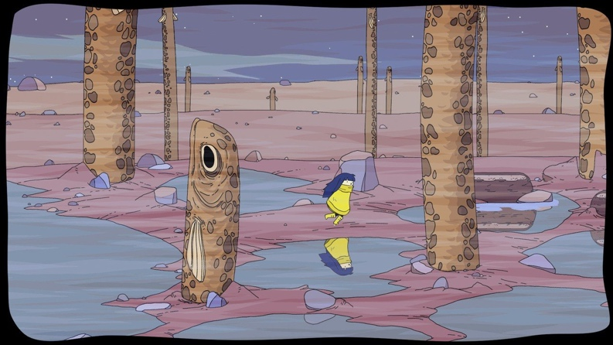

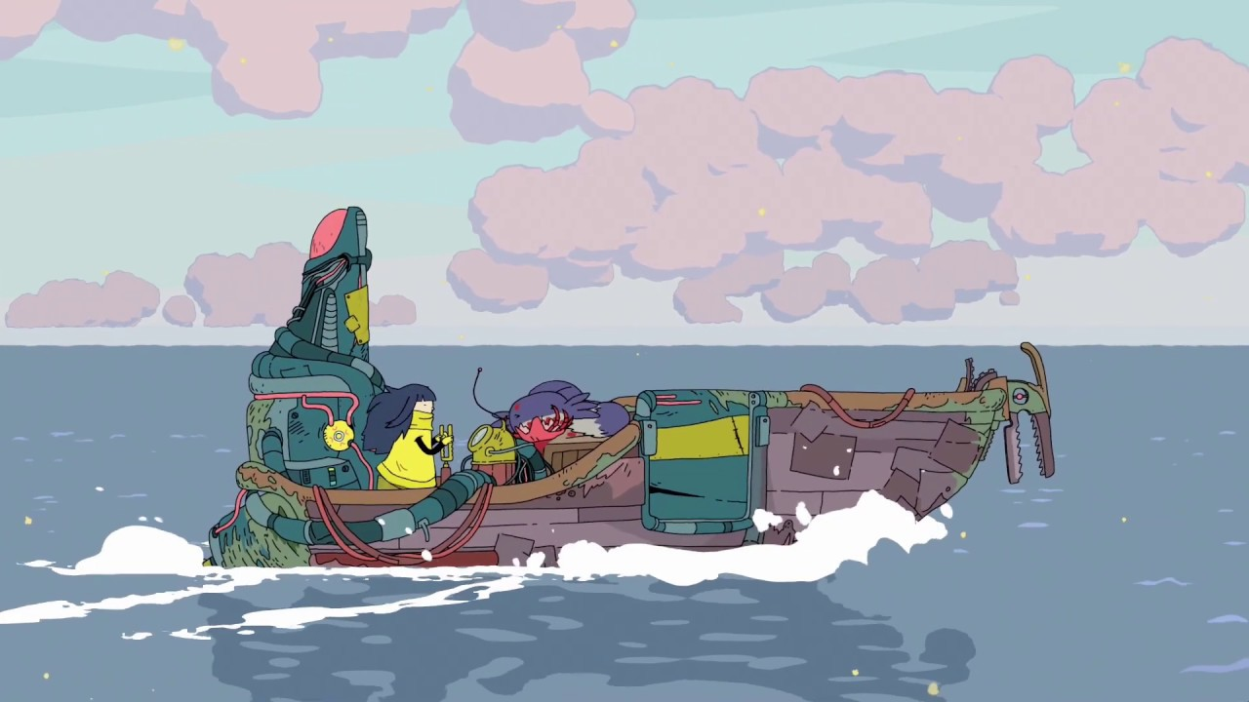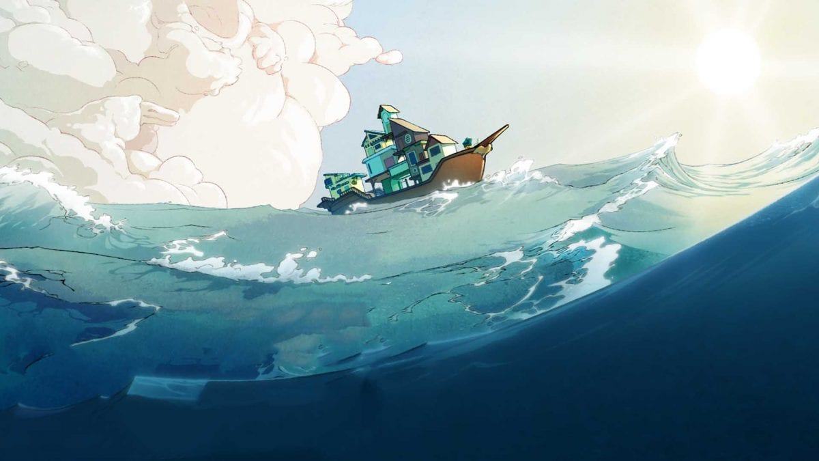

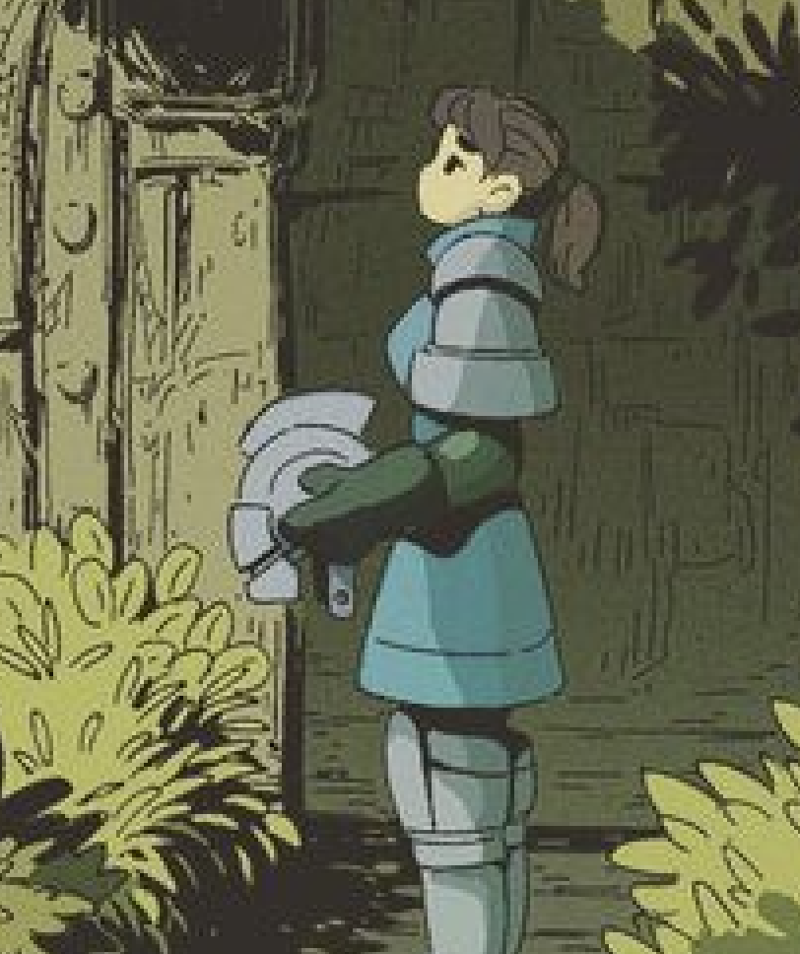**DETAIL EXAMPLES**

Lineart on the character itself is very simple with few details while the background relies on heavy use of accent lines to imply detail. Shading on both character and background are kept simple, using a colour overlay and simple lighting direction to give sense of atmosphere.

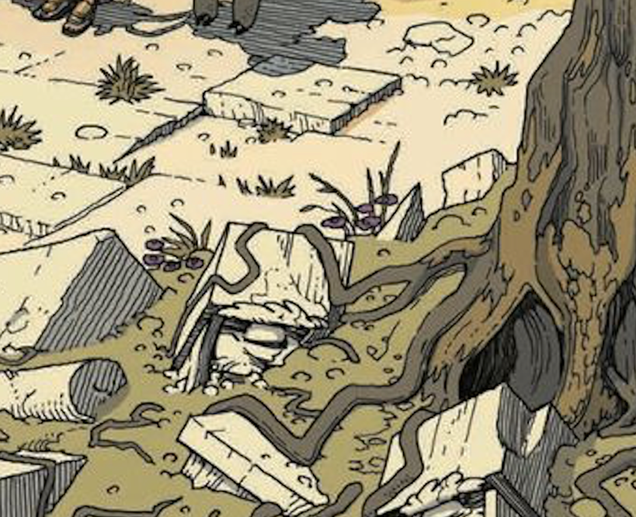

Background is very detailed with lines to create noise and illusion of a lot going on when in reality there isn’t. Helps the scene to feel busy without it being busy.

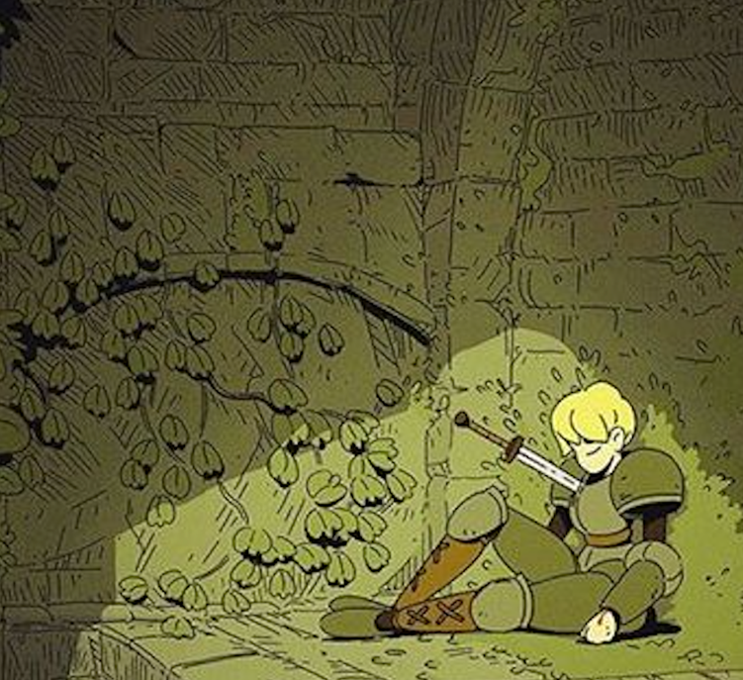Another example where character itself is very simply lined and shaded/lit, but the background itself looks very complex with heavy use of lines/cross-hatching. But as lighting is focused on the character and the lines are less heavy the closer towards the character it doesn’t pull focus.